Name: Aishmeen kaur

Student Id: 415076

Course Name: Mobile Application Development

[Email:aishmeen2001kaur14@gmail.com](mailto:Email:aishmeen2001kaur14@gmail.com)

PROJECT PROPOSAL

In this project the name of my app is Foodie Zone. This Foodie zone app is a delivery app from which people can easily order food of their choice. There will be a variety of food items that this food delivery app will provide.

WIREFRAMES

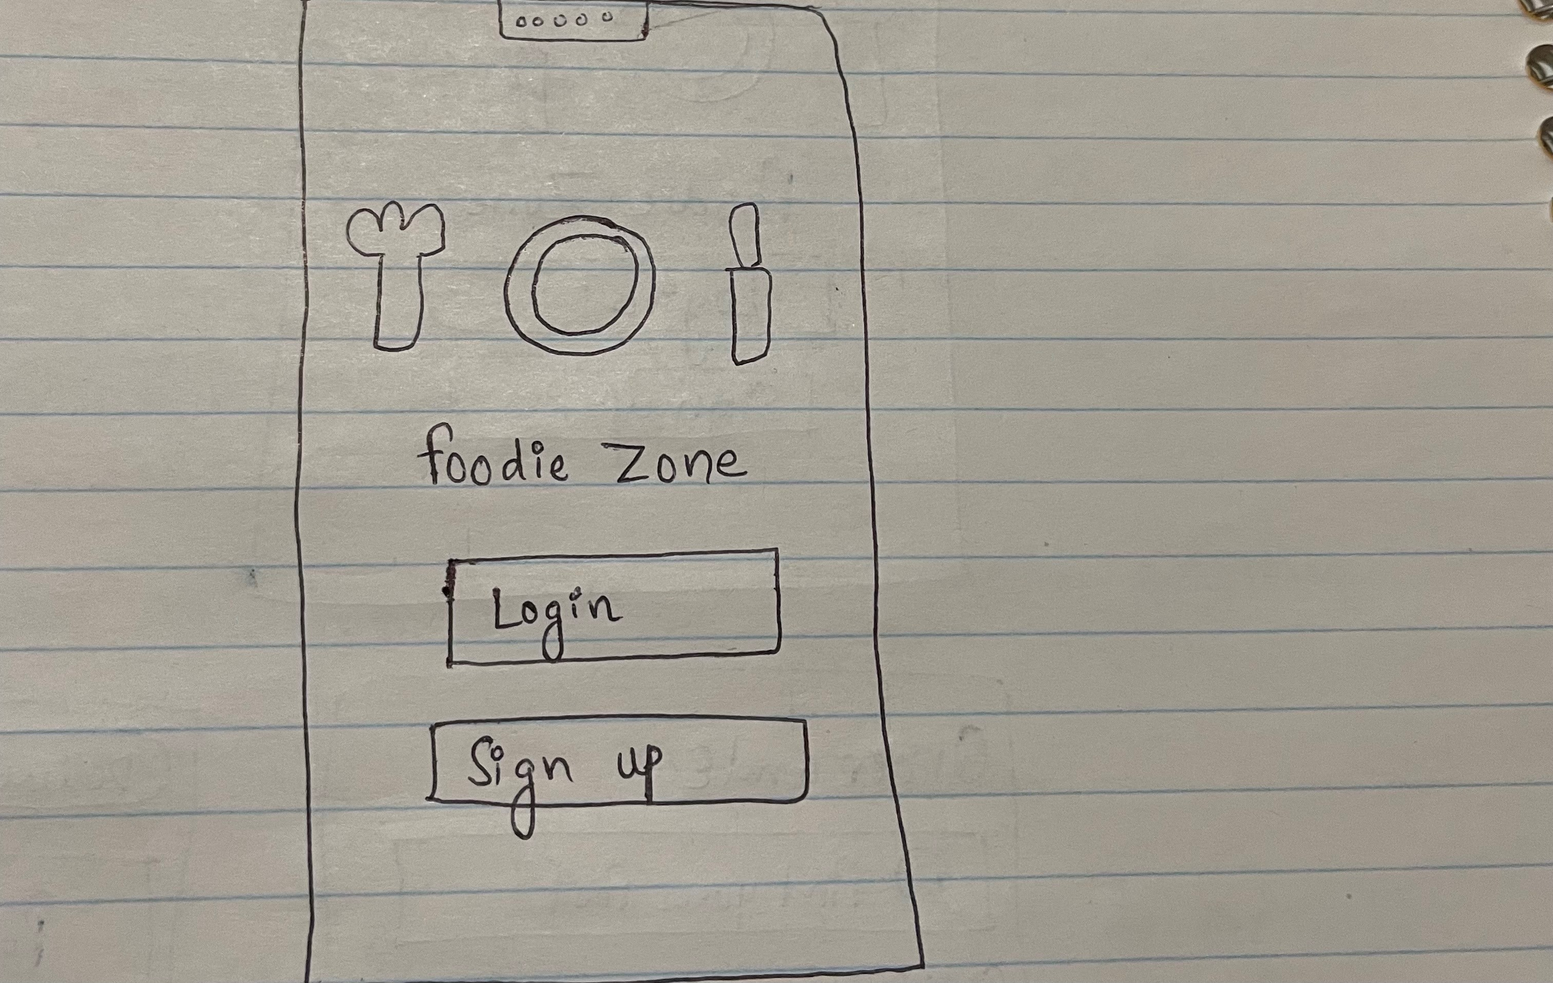

This is the first screen of my android food delivery app. This is a login screen from where user can create an account in foodie zone app and can easily access all the features and by creating an account in foodie zone user can have all the notifications related to this app.

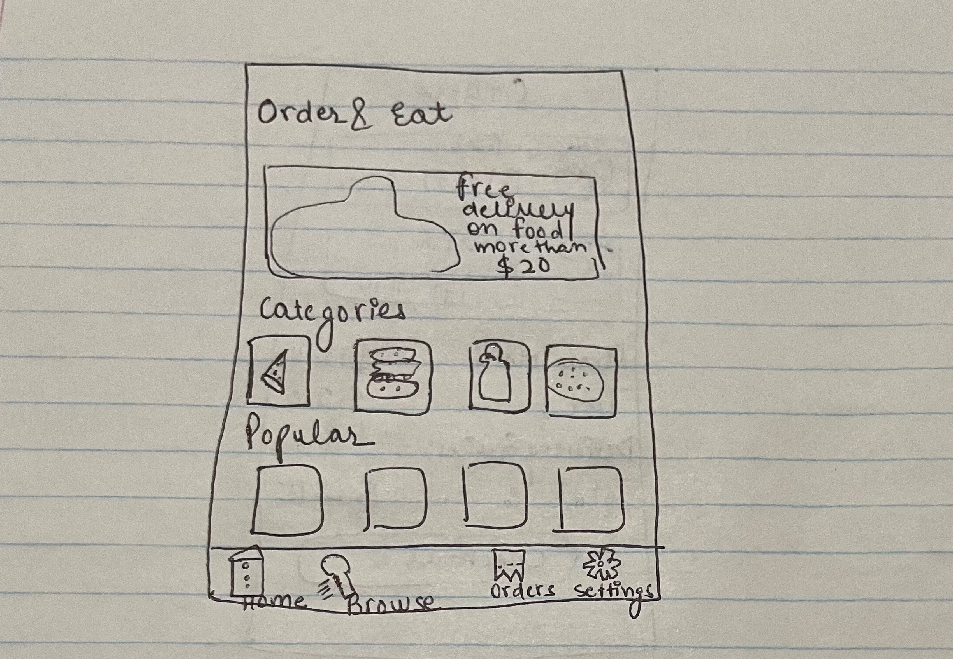

This is the second screen of my Foodie zone app. This is homepage screen where user will get the overall overview of the app. Homepage of the foodie zone app describes the app in brief. It gives a brief description regarding various categories of food and all the popular food items. Moreover, from the popular section users can easily make a choice of their favorite food and can even try distinct kinds of popular food items.

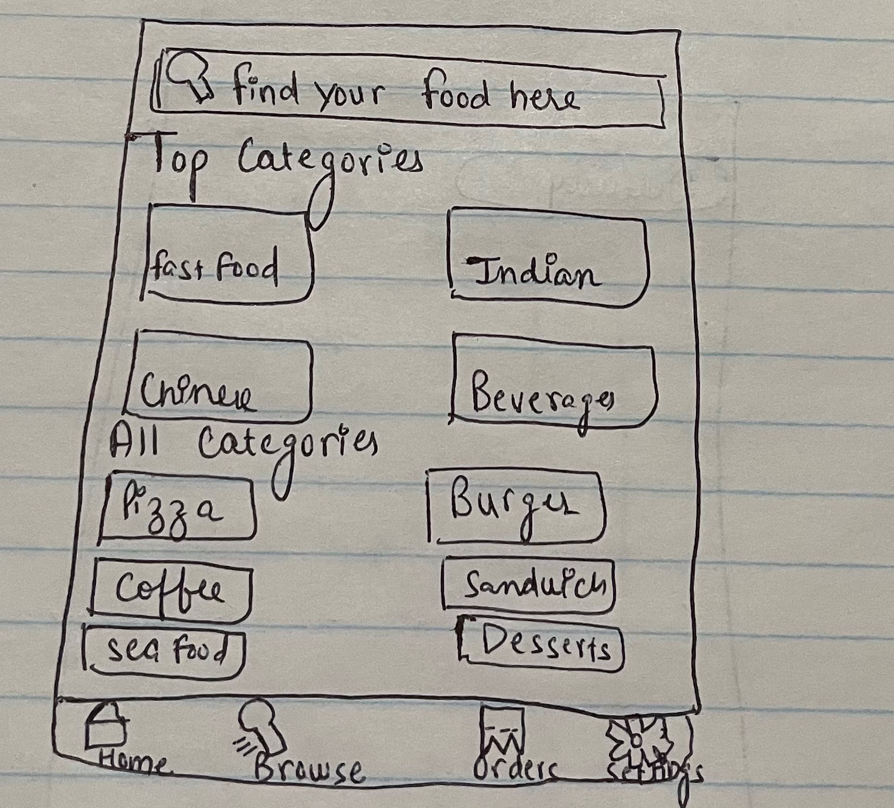

This is the third screen of my android Foodie zone app. This is a browse screen of Foodie zone app. In this browse screen users can easily find the food of their choice as all the food will be available according to distinct categories. For instance, if users want to choose Indian food they can simply click on Indian food and all the items under Indian food will be available.

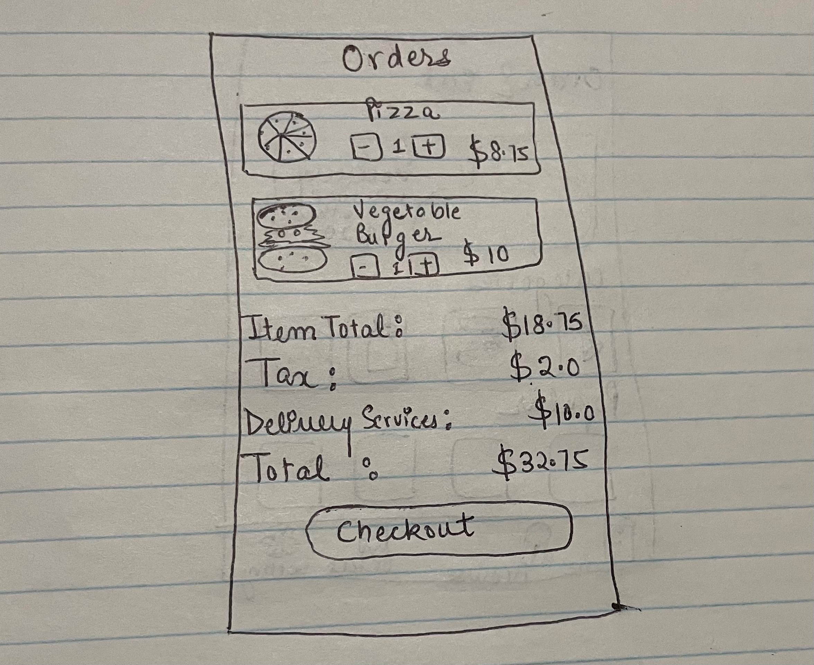

This is the fourth screen of my android Foodie Zone app. Food orders placed by users will appear on this screen. The price of all the ordered food items will appear on this screen and users can finish their payment procedure on clicking checkout.